МИНОБРНАУКИ РОССИИ

Федеральное государственное бюджетное образовательное

учреждение высшего образования

НИЖЕГОРОДСКИЙ ГОСУДАРСТВЕННЫЙ ТЕХНИЧЕСКИЙ УНИВЕРСИТЕТ

ИМ. Р.Е. АЛЕКСЕЕВА

ИНСТИТУТ РАДИОЭЛЕКТРОНИКИ И ИНФОРМАЦИОННЫХ ТЕХНОЛОГИЙ

|  |  |  |
| --- | --- | --- |
|  |  |  |

Курс “Аппаратное и программное обеспечение роботизированных систем”

Отчет по лабораторной работе №3

Выполнил: Яканин А.В

Проверил: Гай В.Е.

Нижний Новгород   
2021

**Тема работы:**

Классификация изображений с использованием свёрточных нейронных сетей.

**Задание:**

Выполнить анализ статьи, разобрать структуру сети, реализовать сеть в Keras, оценить точность работы сети.

Вариант данных: CIFAR10

Вариант модели сети: ResNet50

**Листинг программы:**

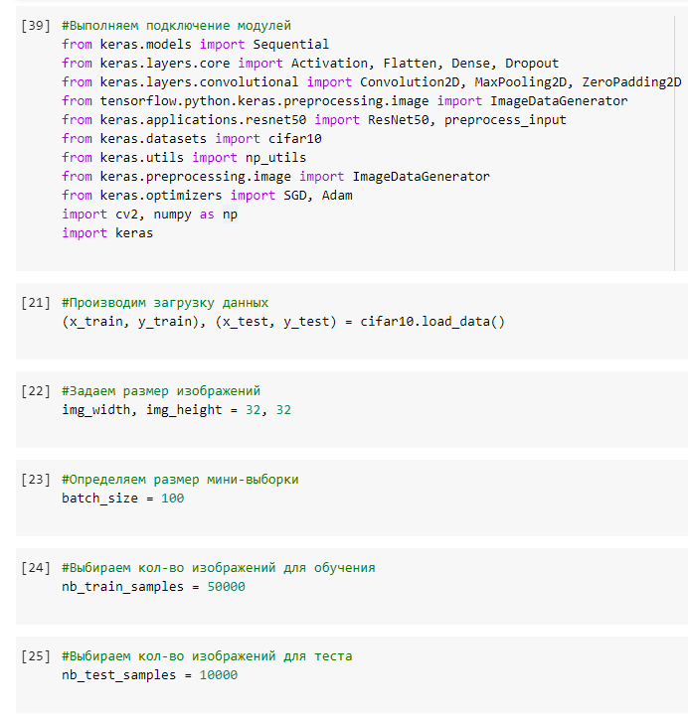

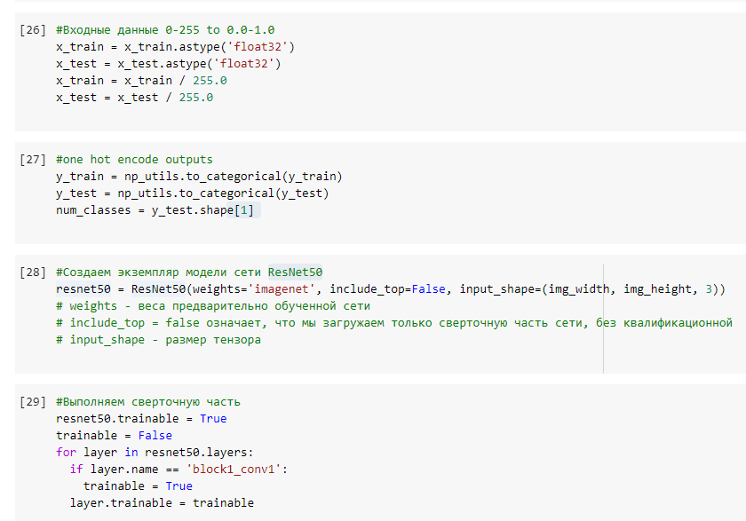

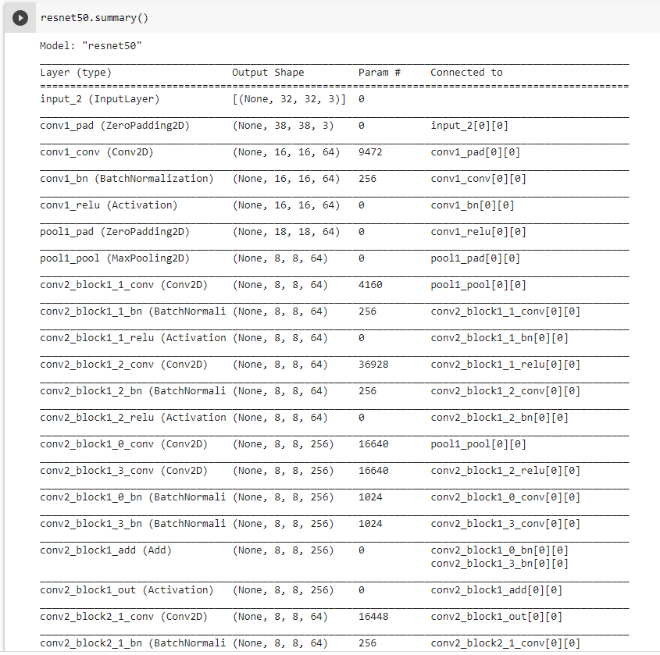

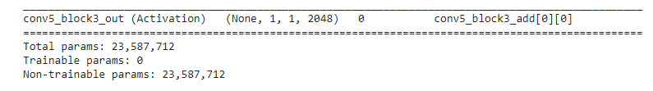

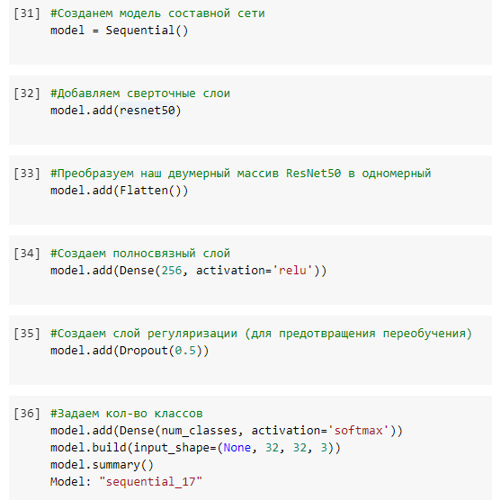

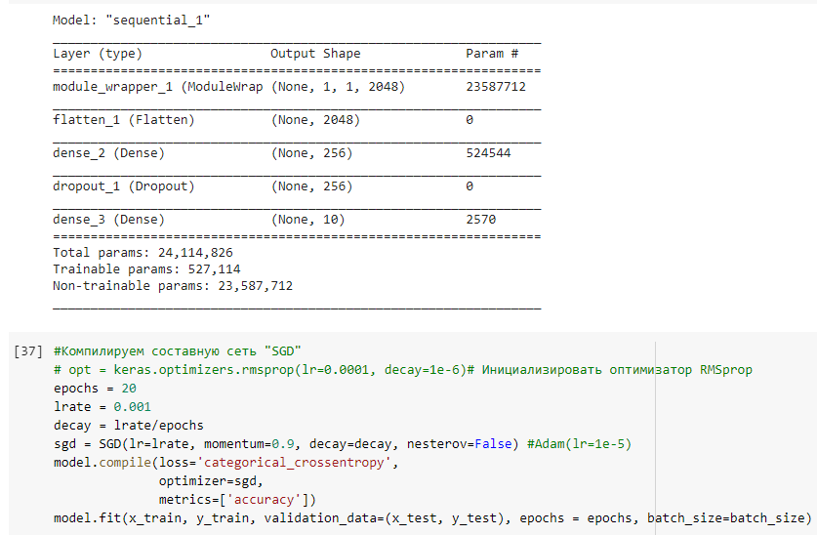

Epoch 1/20

500/500 [==============================] - 17s 32ms/step - loss: 1.5561 - accuracy: 0.4458 - val_loss: 0.7625 - val_accuracy: 0.7180

Epoch 2/20

500/500 [==============================] - 16s 31ms/step - loss: 0.7379 - accuracy: 0.7504 - val_loss: 0.6465 - val_accuracy: 0.7443

Epoch 3/20

500/500 [==============================] - 16s 31ms/step - loss: 0.5811 - accuracy: 0.8060 - val_loss: 0.6570 - val_accuracy: 0.7615

Epoch 4/20

500/500 [==============================] - 15s 30ms/step - loss: 0.4934 - accuracy: 0.8351 - val_loss: 0.5178 - val_accuracy: 0.7821

Epoch 5/20

500/500 [==============================] - 16s 31ms/step - loss: 0.4119 - accuracy: 0.8620 - val_loss: 0.4948 - val_accuracy: 0.8040

Epoch 6/20

500/500 [==============================] - 16s 31ms/step - loss: 0.3511 - accuracy: 0.8809 - val_loss: 0.4897 - val_accuracy: 0.8022

Epoch 7/20

500/500 [==============================] - 15s 30ms/step - loss: 0.2960 - accuracy: 0.8999 - val_loss: 0.4969 - val_accuracy: 0.8122

Epoch 8/20

500/500 [==============================] - 15s 31ms/step - loss: 0.2606 - accuracy: 0.9117 - val_loss: 0.5261 - val_accuracy: 0.7821

Epoch 9/20

500/500 [==============================] - 16s 31ms/step - loss: 0.2044 - accuracy: 0.9311 - val_loss: 0.4601 - val_accuracy: 0.8023

Epoch 10/20

500/500 [==============================] - 16s 31ms/step - loss: 0.1696 - accuracy: 0.9439 - val_loss: 0.4897 - val_accuracy: 0.7916

Epoch 11/20

500/500 [==============================] - 15s 31ms/step - loss: 0.1374 - accuracy: 0.9558 - val_loss: 0.5055 - val_accuracy: 0.8026

Epoch 12/20

500/500 [==============================] - 15s 31ms/step - loss: 0.1187 - accuracy: 0.9612 - val_loss: 0.5299 - val_accuracy: 0.8276

Epoch 13/20

500/500 [==============================] - 15s 31ms/step - loss: 0.0913 - accuracy: 0.9702 - val_loss: 0.5611 - val_accuracy: 0.8321

Epoch 14/20

500/500 [==============================] - 15s 31ms/step - loss: 0.0718 - accuracy: 0.9777 - val_loss: 0.5739 - val_accuracy: 0.8163

Epoch 15/20

500/500 [==============================] - 16s 31ms/step - loss: 0.0518 - accuracy: 0.9852 - val_loss: 0.6376 - val_accuracy: 0.8031

Epoch 16/20

500/500 [==============================] - 16s 31ms/step - loss: 0.0500 - accuracy: 0.9852 - val_loss: 0.6121 - val_accuracy: 0.7926

Epoch 17/20

500/500 [==============================] - 16s 31ms/step - loss: 0.0399 - accuracy: 0.9884 - val_loss: 0.6536 - val_accuracy: 0.801

Epoch 18/20

500/500 [==============================] - 15s 31ms/step - loss: 0.0319 - accuracy: 0.9907 - val_loss: 0.6815 - val_accuracy: 0.8235

Epoch 19/20

500/500 [==============================] - 16s 31ms/step - loss: 0.0244 - accuracy: 0.9925 - val_loss: 0.7077 - val_accuracy: 0.8564

Epoch 20/20

500/500 [==============================] - 16s 31ms/step - loss: 0.0255 - accuracy: 0.9928 - val_loss: 0.7032 - val_accuracy: 0.8610

<keras.callbacks.History at 0x7fe609a0fe90>

#Считаем финальную точность

scores = model.evaluate(x_test, y_test, verbose=0)

print("Accuracy: %.2f%%" % (scores[1]*100))

Accuracy: 81.17%

Итоговая точность равна: 81.17%